**Flop CBet Single Rsd Pot** (CB) **Turn CB SRP** (DB)

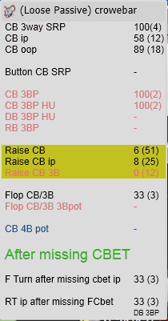 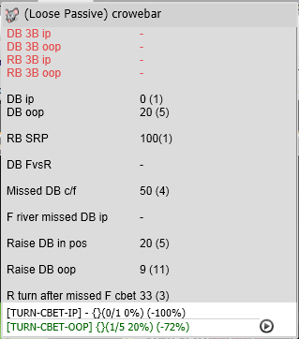

**River CB SRP** (RB)  **Flop Fold to CB SRP** (FCB)

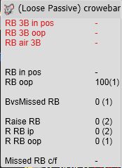 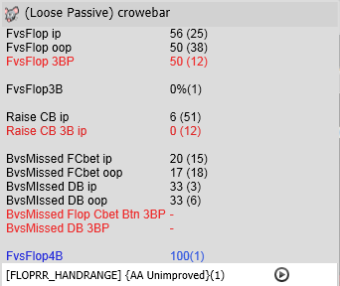

**Turn Fold to CB SRP** (FDB)  **River Fold to CB SRP** (FRB)

